**Learning Management System – Student Module**

Home Screen

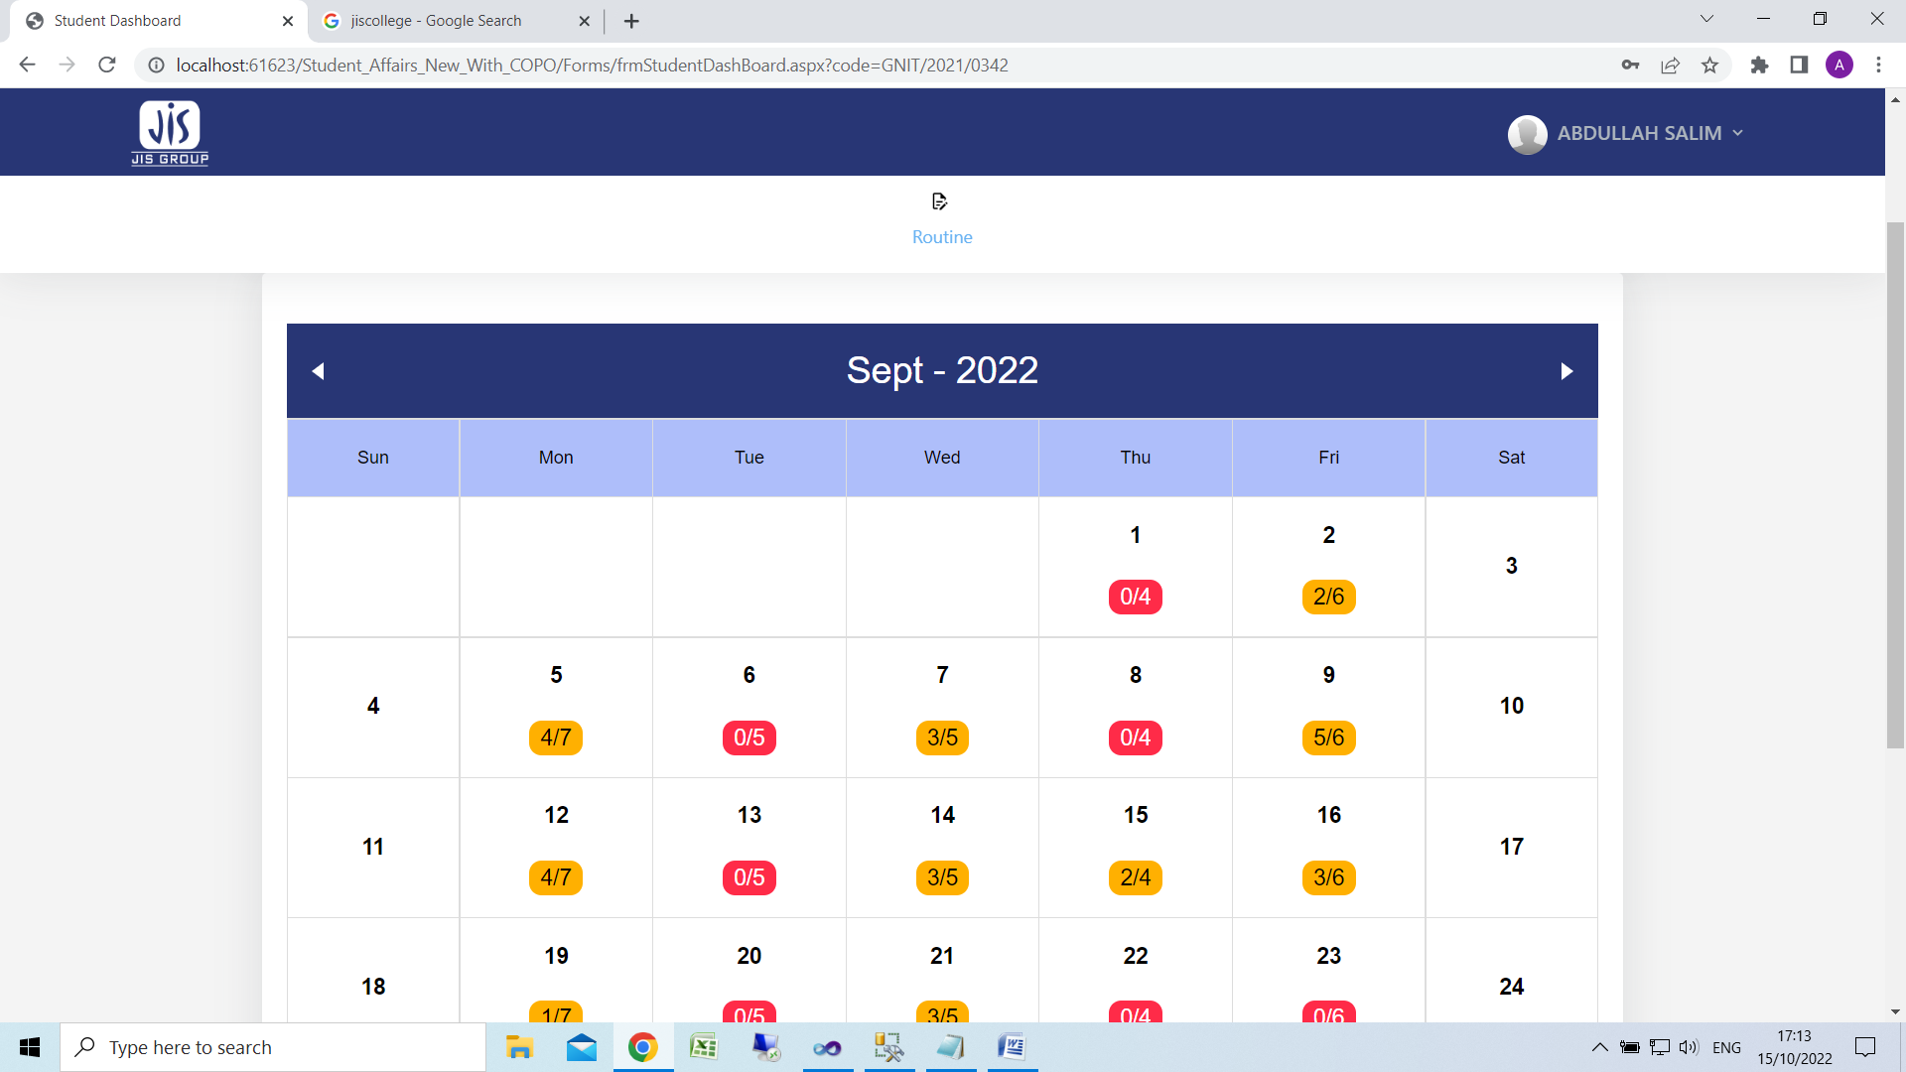

Click on Date to view details

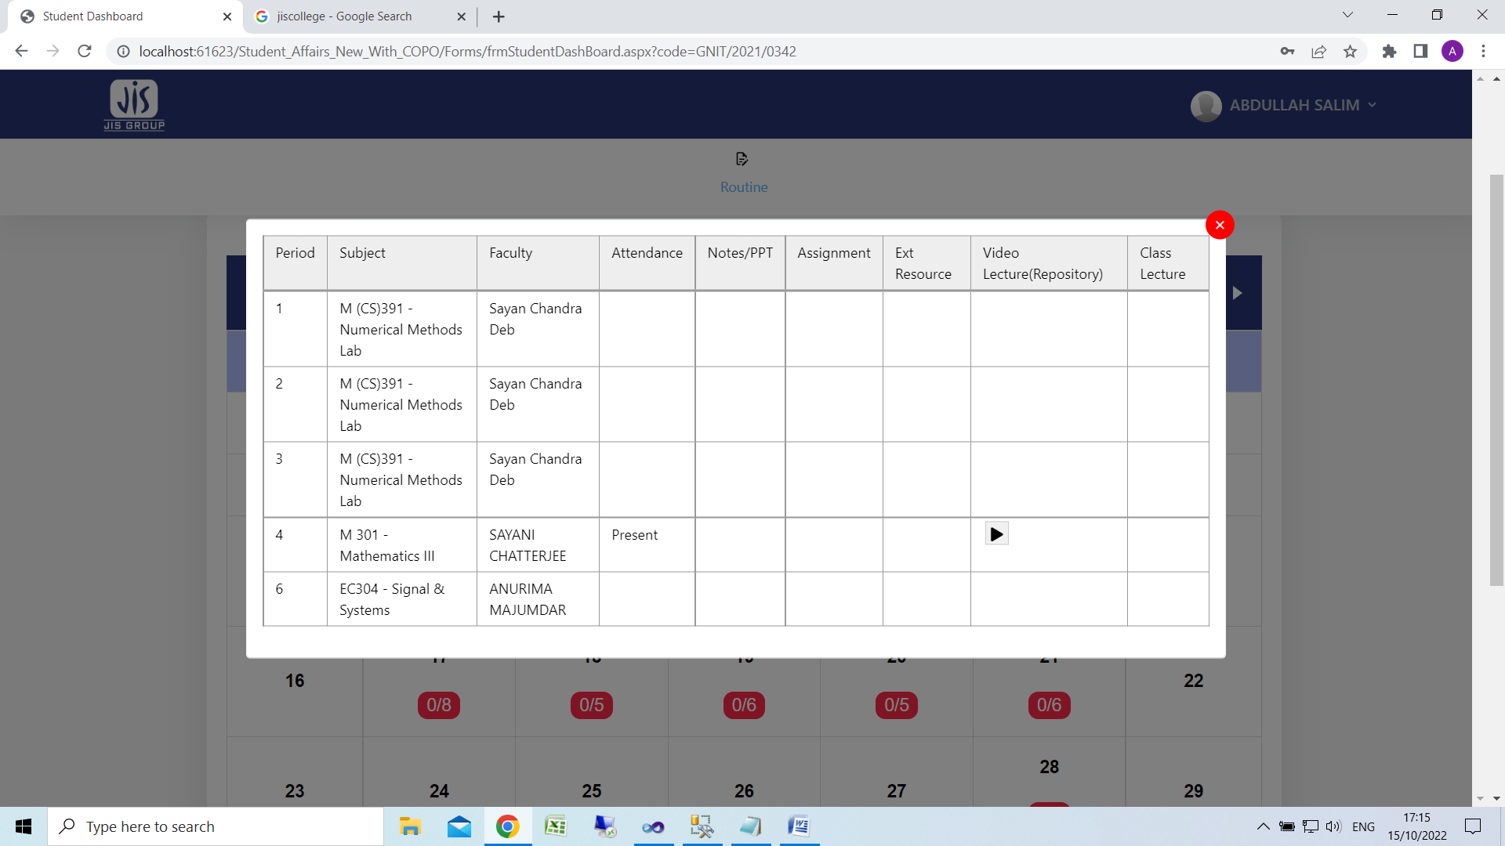

Click on play button to view/download class notes